{Course: Keep My Girl or Boy Safe and Healthy}

{Lesson: Teaching Safe Touch (Age 2-5/M & F)}
Script | On Slide Text | Animation Notes
Hi, you’re back on Crianza con Conciencia Positiva, fantastic!  This course is about keeping your girl or boy safe and healthy. Today, we will talk about teaching your girl or boy safe and unsafe touch.  Here are four helpful tips to guide you in teaching your girl or boy about safe and unsafe touch and what to do if they ever feel uncomfortable when someone touches them.  Ready to learn more? | Teaching Safe Touch
First, learn about private parts.  Teach your girl or boy that the parts of their bodies that go under their underwear or a swimsuit are private parts. It is not okay for other people to touch or look at their private parts  [pause]  It is also not okay for someone to ask your girl or boy to touch or look at someone else’s private parts.  [pause]  Second, teach your girl or boy that it’s okay to say no.  Tell your girl or boy that they are always allowed to say no to someone touching them even if they are family or friends. This is true even for things like hugs! This teaches your girl or boy that they are always in control of who they allow to touch them so they can make safe choices throughout their lives, in any situation. You can practise saying “No, please don’t do that” and “No! Stop!” with your girl or boy so they know how to do it if they need to.  The next tip is to get away.  Always teach your girl or boy how to get away from any situation where they feel uncomfortable. In most of the cases, offenders are not strangers to the girl or boy. They are usually known to the girl or boy and/or caregivers. When playing physical games like wrestling with your girl or boy, practice saying "no" and respecting their boundaries. If your girl or boy says "no", stop the game immediately.  [pause]  This empowers them to say “NO!” to unsafe situations outside the home as well.  It will not be easy for your girl or boy to get away from such situations, but teaching them how to leave uncomfortable or unsafe situations will be a valuable skill for life.  [pause]  Finally, teach your girl or boy to tell an adult.  Tell your girl or boy that if they feel worried, uncomfortable, or unsafe about anyone touching them, they should tell you or an adult they trust.  [pause]  If your girl or boy tells you about something that has happened, listen openly and tell them they were right to tell you. Then, take steps to keep them safe. Always believe your girl or boy, and don’t leave them alone with the person they feel unsafe with. | LEARN ABOUT PRIVATE PARTS  “NO” IS OK!  GET AWAY  TELL AN ADULT | Animate words to text
Remember, to teach your girl or boy about safe touch, follow the four tips - learn about private parts, saying “no” is okay, how to get away, and tell an adult.  Your home activity is to have a conversation with your girl or boy about safe and unsafe touch. Help them practise saying, “No, don’t do that!” or “No! Stop!” and remind them to tell an adult if it happens.  Can you do this with your girl or boy today? | Teaching Safe Touch  LEARN ABOUT PRIVATE PARTS  “NO” IS OK!  GET AWAY  TELL AN ADULT  HOME ACTIVITY  Have a conversation about safe and unsafe touch.

{Lesson: Teaching Safe Touch (Age 6-9)}
Script | On Slide Text | Animation Notes
Hi, you’re back on Crianza con Conciencia Positiva, fantastic!  This course is about keeping your girl or boy safe and healthy. Today, we will talk about teaching safe touch.  Here are five tips to help you teach your girl or boy about safe touch and what to do if they feel unsafe when someone touches them.  Ready to learn more? | Teaching Safe Touch
The first tip is, be honest.  Talk to your girl or boy about how to name each part of their body. If your girl or boy knows how their body works and where people should and should not touch them, they can make safer choices throughout their lives.  Answer any question your girl or boy asks you honestly. These could be about any part of their own body or that of the other sex - even private parts!  This teaches them it is safe to ask about the body, which means they will learn more and stay safer.  Teaching your girl or boy about their whole body, even when young, means they will know how to talk about it if anything happens that they feel is unsafe. | BE HONEST about how to name body parts and how bodies work
The second tip is to teach your girl or boy that it’s okay to say no.  Tell your girl or boy that they are always allowed to say no to someone touching them even if they are family or friends. This is true even for things like hugs!  This teaches your girl or boy that they are always in control of who they allow to touch them so they can make safe choices throughout their lives, in any situation.  You can practise saying “No, please don’t do that” and “No! Stop!” with your girl or boy so they know how to do it if they need to. | “NO” IS OK!  Practice saying “No, please don’t do that” and “No! Stop!”
The third tip is to get away.  Always teach your girl or boy how to get away from any situation where they feel uncomfortable. In most of the cases, offenders are not strangers to the girl or boy. They are usually known to the girl or boy and/or caregivers. When playing physical games like wrestling with your girl or boy, practice saying "no" and respecting their boundaries. If your girl or boy says "no", stop the game immediately.  [pause]  This empowers them to say “NO!” to unsafe situations outside the home as well.  It will not be easy for your girl or boy to get away from such situations, but teaching them how to leave uncomfortable or unsafe situations will be a valuable skill for life. | GET AWAY from situations where your girl or boy feels uncomfortable
Next, tell an adult.  Tell your girl or boy that if they feel worried, uncomfortable, or unsafe about anyone touching them, they should tell you or an adult they trust.  [pause]  If your girl or boy tells you about something that has happened, it is important that you listen openly and tell them they were right to tell you. Then, take steps to keep them safe. | TELL AN ADULT about anything uncomfortable or unsafe
Our final tip is, respond.  You might need to help your girl or boy talk about their feelings or redirect their focus.  [PAUSE]  You might need to talk about the actions that you or your girl or boy could take to help with what has happened.  [PAUSE]  You can teach your girl or boy consequences later if needed. In the moment, your girl or boy needs you to be there for them with love.  ✅ Remember, you can always type HELP in Crianza con Conciencia Positiva and get information about resources in your community where you can receive help. | RESPOND  What help is needed right now?  Type HELP on Crianza con Conciencia Positiva
Remember, to teach your girl or boy about safe touch, follow the five tips - be honest, saying “no” is okay, how to get away, tell an adult, and get help.  Your home activity for today is to have a conversation with your girl or boy about safe and unsafe touch. Help them practise saying, “No, don’t do that!” and remind them to tell an adult if it happens.  Can you do this with your girl or boy today? | Teach Safe Touch  BE HONEST  “NO” IS OK!  GET AWAY  TELL AND ADULT  RESPOND  HOME ACTIVITY  Have a conversation about safe and unsafe touch.

{Lesson: Community Safety (2-4)}
Script | On Slide Text | Animation Notes
Hello, it is great to see you again on Crianza con Conciencia Positiva!  This lesson is about learning how to keep Your girl or boy safe in your community.  One thing you can do to help keep your girl or boy safe is to talk with them about which places are safe to go and which are not, and teach them how to be careful when they meet people they don't know.  Here are four steps to help you with this conversation:  Draw  [pause]  talk,  [pause]  discuss,  [pause]and practice.  Let’s learn more together! | Being Safe in the Community  DRAW  TALK  DISCUSS  PRACTICE
The first step is to DRAW.  With your girl or boy, draw a map of your community. Include all the main places in your community on the map, like your house, streets in your neighbourhood, pre-school, daycare, and other places you and your girl or boy might go to. [1]  Draw and identify pictures of trusted people who your girl or boy can go to when they feel unsafe. These can be you and your partner, other family members, or their teachers. | DRAW | Begin with a blank sheet. Animate on [1]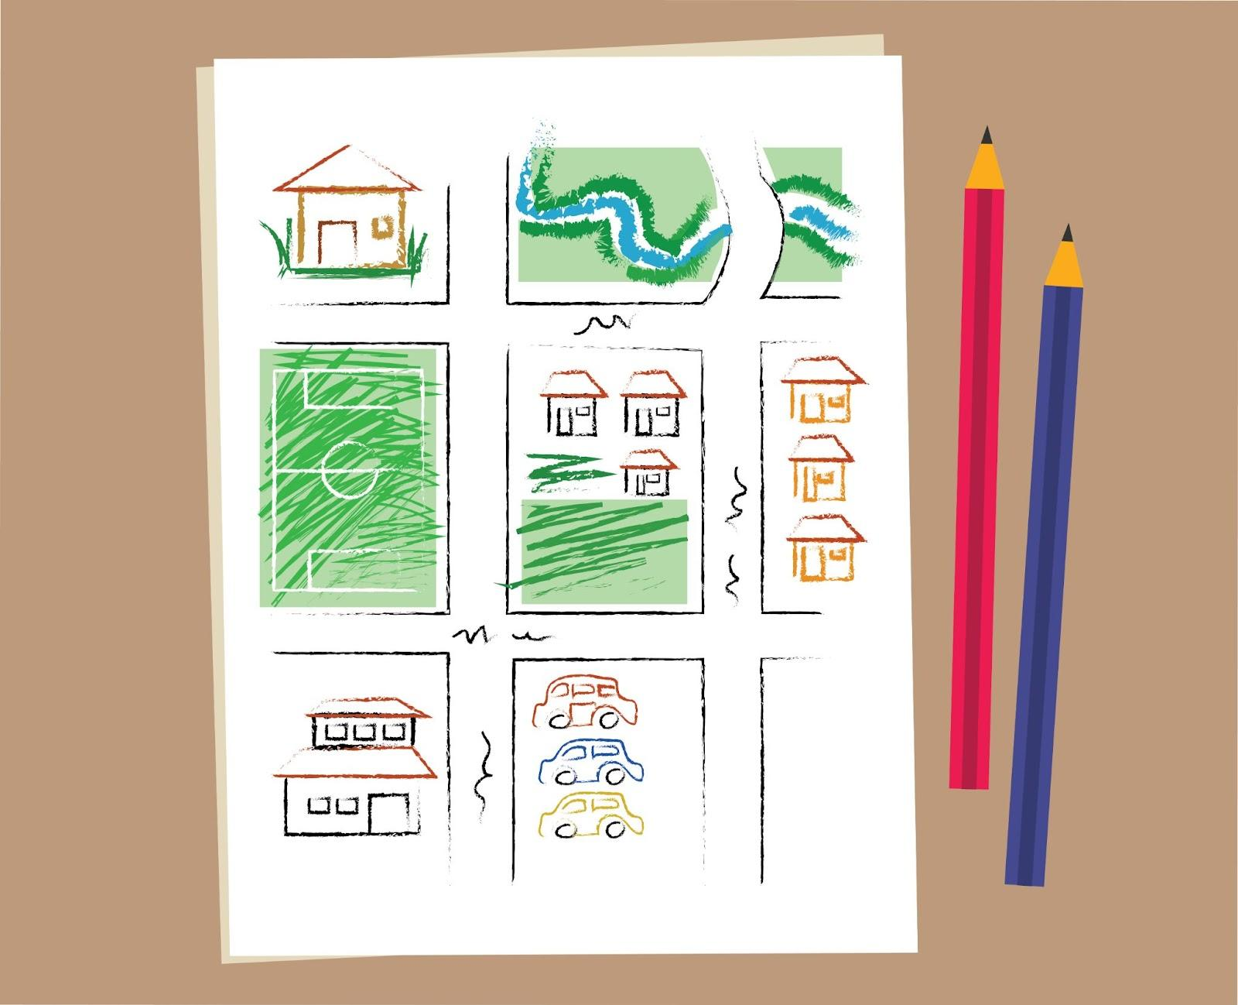
The next step is to TALK.  Talk about the safe and unsafe places on your map. For example, let your girl or boy know that the street is not a safe place, even if their toy or ball goes there.  [1] CIRCLE the places that are safe for girls and boys. CROSS OFF any places that are unsafe for your girl or boy. For example, areas under construction, parking areas, or unfamiliar buildings. | TALK | Begin with the previous sheet. Animate on [1]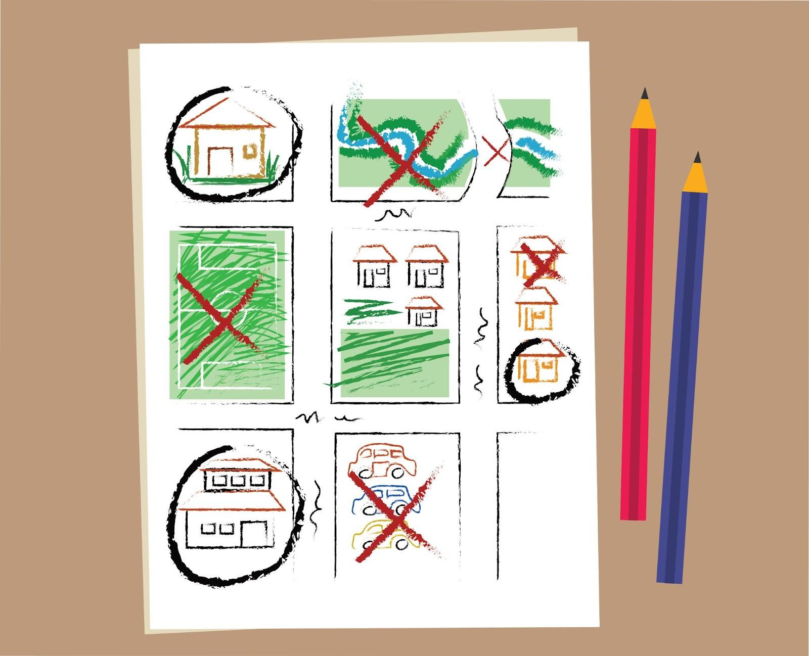
The third step is to DISCUSS. Discuss with your girl or boy why it is important to ALWAYS have an adult with them when they go outside. Make sure your girl or boy knows it’s okay to walk or run inside if a stranger tries to talk to them or asks them to go somewhere. Discuss with your girl or boy safe places they can run if a stranger approaches them – such as your home, or a neighbour’s home.  [1] Mark these areas clearly on your map. | DISCUSS | Begin with the previous sheet. Animate on [1]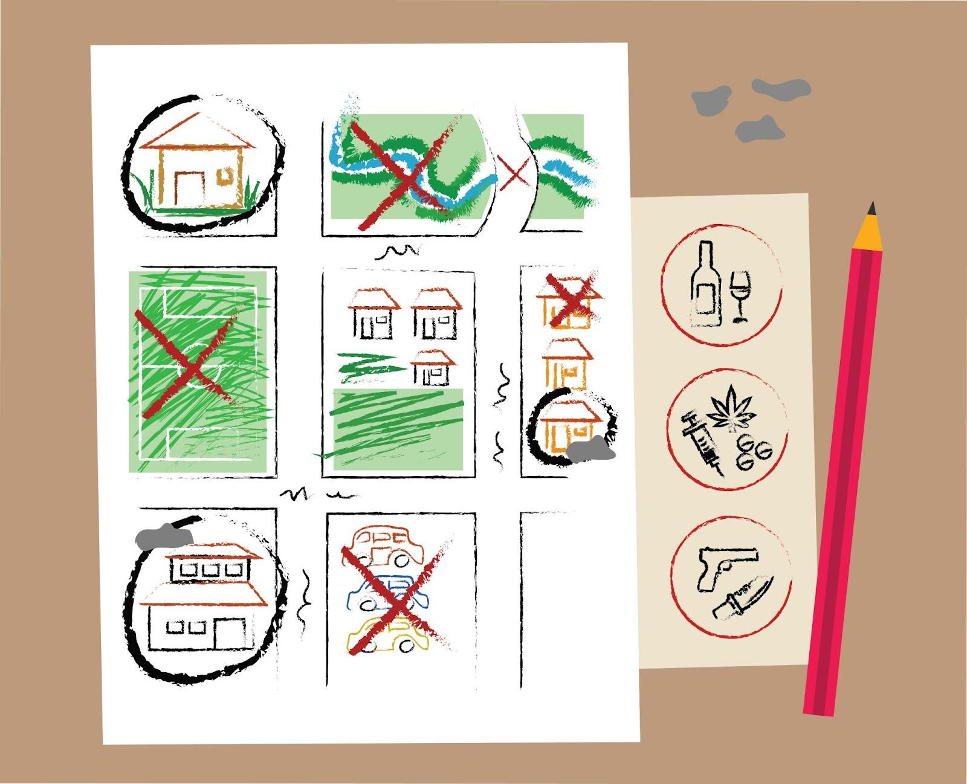
The last step is to practice, practice, practice!  Using toys or puppets, role-play scenarios where a stranger approaches. Ask your girl or boy what the toy should do. Girls and boys find it less scary to pretend that someone else is in danger.  Remember to praise them when your girl or boy chooses the correct response, such as running away, shouting for help, or finding a trusted adult. | PRACTICE  Role-play using toys or puppets  Remember to praise
Talking about unsafe situations with your girl or boy might feel uncomfortable, but it's important. When girls and boys know what to do in a dangerous situation, they're much safer.  Your home activity is to have a conversation with your girl or boy about which places are safe or unsafe for girls and boys in your community. Do you have time to do it today? | Being Safe in the Community  HOME ACTIVITY  Have a conversation with your girl or boy about safe and unsafe places in your community

{Lesson: Community Safety (5-9)}
Script | On Slide Text | Animation Notes
Hello! This course is all about keeping your girl or boy safe and today we are learning about community safety.  One thing you can do to help keep your girl or boy safe is to talk with them about which places are safe to go and which are not, and teach them how to be careful when they meet people they don't know.  Here are four steps to help you with this conversation:  Draw  [pause]  talk,  [pause]  discuss,  [pause]and practice.  Let’s learn more together! | Being Safe in the Community  DRAW  TALK  DISCUSS  PRACTICE
The first step is to DRAW.  With your girl or boy, draw a map of your community. Include all the main places in your community on the map, like your house, streets in your neighbourhood, school, shops, and other places you and/or your girl or boy might go to. [1]  Draw and identify pictures of trusted people who your girl or boy can go to when they feel unsafe. These can be you and your partner, other family members, or their teachers. | DRAW | Begin with a blank sheet. Animate on [1]
The next step is to TALK.  Talk about the places on your map and decide if they are safe or not.  Make sure you listen to your girl or boy. It is important to understand why they think a place is safe or unsafe.  [1] CIRCLE the places that are safe for girls and boys. CROSS OFF any places that are unsafe for your girl or boy. For example, areas under construction, parking areas, or unfamiliar buildings. | TALK | Begin with the previous sheet. Animate on [1]
The third step is to DISCUSS.  Sometimes, we find ourselves in trouble. Make sure your girl or boy knows it’s okay to walk or run inside if a stranger tries to talk to them or asks them to go somewhere. Discuss where you and your girl or boy can get support in a crisis. These places may include home, school, clinic or an institution you trust.  [1] Mark these areas clearly on your map. | DISCUSS | Begin with the previous sheet. Animate on [1]
Finally, practice! Practice! Practice!  Role-play scenarios where a stranger approaches using toys or puppets. Ask your girl or boy what the toy should do. Girls and boys find it less scary to pretend that someone else is in danger. Praise them when your girl or boy chooses the correct response, such as running away, shouting for help, or finding a trusted adult. | PRACTICE  Role-play using toys or puppets  Remember to praise
Talking about unsafe situations with your girl or boy might feel uncomfortable, but it's important. When girls and boys know what to do in a dangerous situation, they're much safer.  Your home activity is to have a conversation with your girl or boy about which places are safe or unsafe for girls and boys in your community. Give space for your girl or boy to share their thoughts, too. They may think a place is unsafe that you thought was safe. Allow them to explain their reasons. Do you have time to do it today? | Being Safe in the Community  HOME ACTIVITY  Have a conversation with your girl or boy about safe and unsafe places in your community

{Lesson: Responding to Crises (2-6)}
Script | On Slide Text | Animation Notes
Hello! In this course we have been learning about keeping your girl or boy safe. In this lesson we are learning about how to respond to your girl or boy in a crisis.  It is important to support your girl or boy when they experience a difficult situation. When helping your girl or boy in a crisis, remember these four things: [pause] breathe, [pause] listen, [pause] respond, [pause] and comfort.  Let’s learn more about these steps together. | Responding to Crises  BREATHE  LISTEN  RESPOND  COMFORT
Firstly, breathe. Stay calm. Ask yourself, “What does my girl or boy need right now?”  Next, listen. Ask your girl or boy what is going on. Let your girl or boy share with you what they need. Sometimes, your girl or boy might be comfortable sharing by drawing or using toys and puppets to tell you what has upset them. Notice what they are feeling and tell them what you notice so they feel heard. Tell your girl or boy that you are there for them and love them. Remember, both girls AND boys could face hard times and crisis situations. Check-in with both.  The third step is to respond. What might help what is going on? You might need to help your girl or boy talk about their feelings or redirect their focus.You might need to talk about the actions that you or your girl or boy could take to help with what has happened.You can teach your girl or boy consequences later if needed. In the moment, your girl or boy needs you to be there for them with love. Remember, you can always type [1]HELP in Crianza con Conciencia Positiva and get information about resources in your community where you can receive help.  [2]  Finally, comfort your girl or boy. Be there for your girl or boy. It can be hard to see your girl or boy feeling upset or confused, but there is a lot you can do to support them.They need you to accept them and comfort them when difficult things are going on. In these moments, maintaining a consistent routine can be particularly helpful. Familiar routines can provide a sense of security and normalcy, helping your girl or boy feel safe again. Remind your girl or boy again that you love them, and thank them for sharing with you. | BREATHE  Remain calm  LISTEN  Listen to your girl or boy and notice what they are feeling  RESPOND  What can help your girl or boy right now?  [1] HELP  COMFORT  Give your girl or boy comfort | Animate words to text  [1] Add a phone with HELP on the screen. Remove it at [2]
It can be difficult to see your girl or boy feeling upset or confused, but remember that there’s plenty you can do to support them during a difficult time. You’ve got this, you’re such a great parent!  Follow these steps whenever your girl or boy shares something difficult. Supporting your girl or boy through a crisis will also teach them how to support others in difficult times.  For your home activity, [1] find a calm time to look at the community map you created with your girl or boy during the previous tip. [2] Talk about possible risks and what they could do to avoid them. [3] Discuss possible actions that you can take with your girl or boy if they happen.  Do you have time to do this today? | Responding To Crises  BREATHE  LISTEN  RESPOND  COMFORT  HOME ACTIVITY: [1] Look at the community safety map  [2] Talk with your girl or boy about possible risks. [3] Discuss what to do if they happen. | Animate sentences to script either as bullets or in paragraph form. Show map from previous activity.  

{Lesson: Respond to Crises (7-9)}
Script | On Slide Text | Animation Notes
Hello! In this course we have been learning about keeping your girl or boy safe. In this lesson we are learning about how to respond to your girl or boy in a crisis.  It is important to support your girl or boy when they experience a difficult situation. When helping your girl or boy in a crisis, remember these four things: [pause] breathe, [pause] listen, [pause] respond, [pause] and comfort.  Let’s learn more about these steps together. | Responding to Crises  BREATHE  LISTEN  RESPOND  COMFORT
The first step is to breathe. You might want to take a pause so you are calm before you ask yourself, “What does my girl or boy need right now?”  Next, listen. Ask your girl or boy what is going on. Let your girl or boy share with you what they need. Sometimes, your girl or boy might be comfortable sharing by drawing or using toys and puppets.  Notice what they are feeling and tell them what you notice so they feel heard. Make sure to avoid criticising them. Tell your girl or boy that you are there for them and love them. Remember, both girls AND boys could face hard times and crisis situations. Check-in with both.  The third step is to respond. What might help what is going on? You might need to help your girl or boy talk about their feelings or redirect their focus.You might need to talk about the actions that you or your girl or boy could take to help with what has happened.You can teach your girl or boy consequences later if needed. In the moment, your girl or boy needs you to be there for them with love.  Remember, you can always [1] type HELP in Crianza con Conciencia Positiva and get information about resources in your community where you can receive help.  [2]  Finally, comfort your girl or boy. Be there for your girl or boy. It can be hard to see your girl or boy feeling upset or confused, but there is a lot you can do to support them.They need you to accept them and comfort them when difficult things are going on. In these moments, maintaining a consistent routine can be particularly helpful. Familiar routines can provide a sense of security and normalcy, helping your girl or boy feel safe again. Remind your girl or boy again that you love them, and thank them for sharing with you. | BREATHE  Remain calm  LISTEN  Listen to your girl or boy and notice what they are feeling  RESPOND  What can help your girl or boy right now?  [1] HELP  COMFORT  Give your girl or boy comfort | Animate words to text  [1] Add a phone with HELP on the screen. Remove it at [2]
It can be difficult to see your girl or boy feeling upset or confused, but remember that there’s plenty you can do to support them during a difficult time. You’ve got this, you’re such a great parent!  Follow these steps whenever your girl or boy shares something difficult. Supporting your girl or boy through a crisis will also teach them how to support others in difficult times.  For your home activity, [1] find a calm time to look at the community map you created with your girl or boy during the previous tip. [2] Talk about possible risks and what they could do to avoid them. [3] Discuss possible actions that you can take with your girl or boy if they happen.  Do you have time to do this today? | Respond To Crises  BREATHE  LISTEN  RESPOND  COMFORT  HOME ACTIVITY: [1] Look at the community safety map  [2] Talk with your girl or boy about possible risks. [3] Discuss what to do if they happen. | Animate sentences to script either as bullets or in paragraph form. Show map from previous activity.  

{Lesson:Knowing Basics of Online Safety}
Script | On Slide Text | Animation Notes
Hi again! Today’s lesson is about how to keep your girl or boy safe online.  Girls and boys are spending a lot of time online. Being connected helps them stay positive and learn more, but there are also some risks and dangers. Keeping your girl or boy safe online is an important step to help them be part of the digital world.  When it comes to online safety, there are four tips to keep in mind:  LEARN,  PROTECT,  BUILD HABITS,  and BUILD TRUST.  There is so much to share. We will cover online safety over two lessons.  [1] Today, we are reviewing the tips [pause] LEARN [pause] and PROTECT.  The next lesson will cover [pause] BUILD HABITS [pause] and BUILD TRUST.  Let’s begin. | Knowing Basics of Online Safety  LEARN  PROTECT  BUILD HABITS  BUILD TRUST | Circle around 1 and 2
First, learn the dangers of being online:  CONTENT: your girl or boy might come across harmful content, such as violence, hateful speech, pornography, or wrong information. This could also include content hating women, people with disabilities, or people following harmful beliefs or agendas that oppose what you want to teach your girls and boys.  CONTACT: Adults might pretend to be girls and boys and ask for sexual pictures or to meet with your girl or boy through an online platform.  CONDUCT: Sometimes, girls and boys or strangers can say or do hurtful things online. | LEARN:  ✅Content  ✅Contact  ✅Conduct | Animate words to text
Next, protect. Keep your girl or boy safe online.  Talk to your girl or boy about which apps and websites are safe and which are not. Discuss why!  Help your girl or boy learn how to make strong passwords to protect their devices.  Tell your girl or boy that they should keep personal information private, including photos or videos of themselves. What goes online stays online! | PROTECT  ✅Talk to your girl or boy about safe apps  ✅Help your girl or boy learn about strong passwords  ✅Tell your girl or boy what should be kept private | Animate words to text
In the next session, we’ll continue learning about online safety. Today, your home activity is to ask your girl or boy what they do to stay safe online. You may find that they are already thinking about online safety.  Praise your girl or boy for any efforts they make. Can you talk with your girl or boy today? | Know Basics of Online Safety  Learn ✅  Protect ✅  Build Habits  Build Trust  HOME ACTIVITY  Ask your girl or boy what they do to stay safe online

{Lesson: Build Habits and Trust Online}
Script | On Slide Text | Animation Notes
Welcome back to Crianza con Conciencia Positiva! This lesson continues our learning about keeping our girls and boys safe online.  Keeping your girl or boy safe online is an important step to help them be part of the digital world.  You already learned ways to protect your girl or boy online with LEARN and PROTECT in the previous lesson.  Today, we are learning how to BUILD HABITS and BUILD TRUST.  Are you ready to begin? | Build Habits and Trust Online  LEARN  PROTECT  BUILD HABITS  BUILD TRUST | Circle number 3 and 4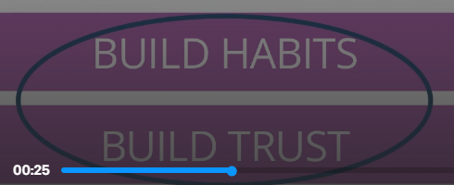
The next step is to BUILD HABITS. Set up safe online habits at home.  Plan phone-free times in your house, like during meals, homework, or in bed.  Set limits on the amount of time your girl or boy spends online.  Only let your girl or boy chat online with people they already know. They should never share personal information in a chat room or with strangers.  Before completing forms that ask for personal information, check that the web address begins with https://. Websites that begin with http:// may not be secure. | BUILD HABITS  - Set phone-free times in your house  - Check web addresses  https://  http:// | Animate to text
For older girls and boys, you can help them create strong passwords for their accounts. Good passwords are:  [pause] long  [pause] do not include obvious personal information like your name or birthday;  [pause] and include upper and lower case letters, numbers and symbols.  Tell your girl or boy not to click on pop-ups that ask them to download or pay for anything. | BUILD HABITS  Set Strong Passwords:  -Long  -Don’t include personal information  -DO include upper and lowercase letters, numbers, and symbols. | ^  Animate password details to explain better.
Finally, BUILD TRUST with your girl or boy  [1]  Together, look at the websites, social media, games, and apps they use.  [2]  Ask questions - this helps you learn more about your girl's or boy's interests! | BUILD TRUST  - Look at websites, social media, games and apps that your girl or boy uses, together  - Ask questions | ^
If you come across anything worrying together, talk about it with your girl or boy. [1]If you need support, type HELP after you complete today’s lesson.  Tell your girl or boy that they should tell an adult if they feel scared, unsafe or upset about something online.  Teach your girl or boy that if a stranger offers gifts, like virtual coins, in exchange for photos and personal information, and tells them to keep it a secret, they should tell you.  Just as you keep your girl or boy safe in the real world, you also need to make sure they are safe in the digital world. By following these steps you can protect them and make sure that their online time is secure so they can keep using it to learn. You’re doing a great job! | BUILD TRUST  - Talk about worrying things together  - Tell your girl or boy if they feel scared or unsafe, they should tell an adult  HELP | ^  [1]Then, animate a phone with HELP on the screen with text.
Here’s something you can do with your girl or boy today to start making sure they stay safe online:  [1]  First, have a conversation with your girl or boy about how they can use the internet and devices in a safe way.  [2]  Next, talk about which sites or apps might be unsafe. Discuss why.  [3]  Finally, praise your girl or boy for how good they are at using the web!  Can you and your girl or boy complete this task today? | Build Habits and Trust Online  HOME ACTIVITY  - Have a conversation with your girl or boy about how they can use the internet and devices in a safe way.  - Talk about which sites or apps might be unsafe and why?  - Praise your girl or boy for how good they are at using the web safely!

{Course: Prepare My Child for Success in School}

{Lesson: Helping Your Girl’s or Boy’s Language Skills}
Script | On Slide Text | Animation Notes
Hello, we are glad to see you back on Crianza con Conciencia Positiva.  This course is all about preparing your girl or boy for success in school by supporting their learning journey. [pause]  Consider the skills we will cover in this course as a guide. Introduce them to your girl or boy when they are ready.  [pause]  Now, let’s jump to today’s skill, it’s all about helping your girl or boy learn new words and improve their language skills.  Ready to get started? | Helping Your Girl’s or Boy’s Language Skills
Try to talk with your girl or boy as often as you can! You can talk about things like their daily activities, how they're feeling, or anything else that you can think of. This helps your girl or boy to improve their memory, speech and vocabulary, as well as help you learn more about them.  Remember, go down to your girl’s or boy’s level when you have a conversation with them. This makes your girl or boy feel confident to speak and shows them that you care.  Here are 5 tips for you on helping your girl or boy to develop language skills through conversations:  Explain,  [pause]  ask,  [pause]  listen,  [pause]  build  [pause]  and tell stories.  Let's learn more together! | EXPLAIN  ASK  LISTEN  BUILD  TELL STORIES
The first tip is to explain.  Talk with your girl or boy by involving them in daily activities. You can describe and explain what you are doing using different words.  For example, if you are shopping at the market, you can say, “Today we are going to buy pieces of corn” or “I am making enchiladas today and we need chicken and chilli for it”.  You can also ask your girl or boy questions and, remember, listen to their answers!  Make sure to give your girl or boy learning opportunities at their own pace. When you give them tasks that suit their abilities, it will boost their confidence and excitement for learning. | EXPLAIN what you are doing
The second tip is to ask.  You can help your girl or boy to talk more by asking questions that don’t have just “yes” or “no” answers. Try asking questions like, “What would you like to do with your friend later?” or, “Did you do anything fun in school today?”  This will help your girl or boy learn new words and also help you learn about their interests and opinions. | ASK questions
The next tip is to listen.  Remember to let your girl or boy speak too.  Give them time to respond - they may need time to think and express, especially if they are giving longer answers!  After giving them time, if it is difficult for them to say what they want to say, you can help them with prompts to encourage them to try new words. | LISTEN to your girl or boy speak
The fourth tip is to build.  Listen carefully to your girl or boy and always respond. Confirm what they said and add more to help them connect their understanding to the new language. For example, if your girl or boy says, “There’s a cat,” you could respond, “Yes, there’s a cat making a big hole in the ground”.  It is important to avoid overcorrecting. Instead of saying, “No, you don’t say sop, you should say soap”, try “Oh right! The little girl is using the **soap** to wash her hands”. | BUILD to the new language
The final tip is to tell stories.  Tell your girl or boy stories! They can be real, made up, about your lives, or you can read to them from books too. Along with telling your girl or boy stories, encourage your girl or boy to tell stories too. You could show photos and create a story together!  You can also use stories to learn new words and incorporate them into various sentences throughout the day.  Remember to be patient! It takes lots of practice to listen to stories, and even more to learn the skill of telling them. | TELL STORIES and encourage your girl or boy to tell stories
As you help build your girl's or boy's language skills, remember the five tips of explain, ask, listen, build, and tell stories.  You are doing great! Your home activity is to try to use words and gestures to describe what you and your girl or boy are doing when you are spending time together. Make sure you communicate in a way that your girl or boy can understand. Can you do it today? | Helping Your Girl's or Boy's Language Skills  EXPLAIN  ASK  LISTEN  BUILD  TELL STORIES  HOME ACTIVITY: Try to use words and gestures to describe what you and your girl or boy are doing

{Lesson: Helping Your Girl or Boy Learn to Read, Part 1}
Script | On Slide Text | Animation Notes
Hi! It’s good to have you with us again on Crianza con Conciencia Positiva.  Today we will learn about helping your girl or boy learn to read. This is the first part of the two-part video.  In this first part we will learn about enjoying books with your girl or boy.  Reading with your girl or boy is the best way to help your girl or boy learn to read.  Girls and boys learn by watching, listening, and copying. When you read to them when they are little, they learn new words. Later they learn letters and letter sounds, and when they’re bigger, reading together can help them learn about anything they are interested in!  Let’s begin! | Helping your Girl or Boy Learn to Read
The four ways to help your girl or boy learn reading skills are  make routines,  [pause]  ask questions,  [pause]  respond and explore,  [pause]  and build and connect.  If reading is difficult for you, don’t worry, just use books with pictures. Describe what you see and talk about the pictures with your girl or boy - this will still help them learn! | MAKE ROUTINES  ASK QUESTIONS  RESPOND AND EXPLORE  BUILD AND CONNECT
Our first tip is to Make routines  You can share books with your girl or boy anywhere! Choose a good place at home to share books. Get rid of any distractions, like turning off the tablet, cell phone or TV. Pick a time every day when you can share books with your girl or boy. If your girl or boy wants to, let them choose a book.  If you don’t have any books in your home - you can use anything with words and pictures, like old magazines or newspapers!  [1]If you want to read some digital books, type BOOKS in Crianza con Conciencia Positiva. | MAKE ROUTINES  Share books with your girl or boy  BOOKS | Phone with the word BOOKS on it at [1]
Second, ask questions.  Look at the book cover together and ask your girl or boy what they think the story might be about. Throughout the book, ask your girl or boy who, what, where, when, why, and how questions. If you have read a story many times, see if your girl or boy knows what comes next! If you are looking at a picture together, describe what’s happening in a picture. Remember to always use language your girl or boy will understand.You can also ask your girl or boy to retell the story. Make sure to allow your girl or boy to ask you questions about the story or the images as well. | ASK QUESTIONS  Who  What  Where  When  Why  How
Our third tip is to respond and explore  Notice what your girl or boy is interested in and talk about it. Help them understand the story, words, sounds, letters, and character emotions. Explore by rephrasing or adding more information - help your girl or boy learn new words and understand the book more. Respond positively and encourage them, even if they are wrong. You can also ask your girl or boy to repeat what you have taught them. | RESPOND AND EXPLORE  Notice what’s interesting and add more information
Finally, build and connect  Help your girl or boy build confidence by asking questions that they might know the answer to or that encourage them to go a bit further with their skill! Remember to always connect what’s in the book to your girl’s or boy’s daily experience. | BUILD AND CONNECT  Build by asking questions and connect to your girl's or boy's experience
Remember, reading with your girl or boy is a great way to help them learn. You can do it by making routines, asking questions, responding and exploring, and building and connecting  Your home activity is to read with your girl or boy. Can you try it today? | Helping your Girl or Boy Learn to Read  HOME ACTIVITY: Read with your girl or boy

{Lesson: Helping Your Girl or Boy Learn To Read, Part 2}
Script | On Slide Text | Animation Notes
Hi, you're back on Crianza con Conciencia Positiva, fantastic!  This is the second part of the two-part video on helping your girl or boy learn to read.  Today, we are learning more about helping your girl or boy become a better reader using word games and writing.  Learning to read begins with understanding language, letters, and sounds. Understanding the sounds in words and starting to write letters will help your girl or boy learn to read.  We will cover four more ways to help your girl or boy learn reading skills and they are:  Use Books to Learn,  [pause]  Notice Letters,  [pause]  Play Word Games,  [pause]  and Start Writing.  Ready to learn more? Let’s get started! | Helping your Girl or Boy Learn to Read  USE BOOKS  NOTICE LETTERS  PLAY WORD GAMES  START WRITING
The first way is to use books to learn.  Books with no words help with imagination, ideas, and learning new words. Together, name and describe what is in the pictures.  Books with words help to understand letters, sounds, and what different words look like. Focus on words that rhyme, repeat, and start with the same letter, like [1]“big black boot.”  Point to each word and say it aloud to help your girl or boy recognise some of the letters and sounds! | USE BOOKS  Name and describe what is in the picture.  Focus on words that rhyme, repeat and start with the same letter.  Big Black Boot | Animate words to text  [1] highlight the B of each word
The second way is to notice letters.  Look for letters everywhere, such as on signs and packages. Point the letters out to your girl or boy and name them. Ask your girl or boy to find letters and name them, too! Remember to praise their effort. | NOTICE LETTERS  Point the letters and name them.
Next, play word games.  Sing and rhyme with your girl or boy to help them learn about the different sounds that make words.  You can also break up names or words into syllables. Clap with your girl or boy while saying each syllable - start with just two!  You can also change some sounds or letters in words to make new words, like “cat, pat, mat.” Then, repeat the sounds that were changed: “c”, “p”, “m”. Practise the letter sounds together.  [2]When you play these word games, help your girl or boy identify “beginning sounds,” “middle sounds,” and “end sounds” - and letters that make these.  Once they understand letters and sounds in different places in words, help your girl or boy put the parts of a word together to make the whole word! | PLAY WORD GAMES  Sing and rhyme  Break up words into syllables, and clap!  Change sounds/letters in words  [1]CAT, PAT, MAT  [2]C - “Beginning sound”  A - “Middle sound”  T - “End sounds” | Animate words to text  [1] and [2]
Finally, start writing.  Encourage your girl or boy to draw. They can start by drawing things they like, such as animals or flowers.  Help them identify their dominant hand by asking: "Which hand do you prefer to draw with? If their response is that they use both hands, allow them to draw with both.  Next, show them how to draw shapes that look like letters, like a circle. Help them practice tracing letters in the air and on a surface with their fingers.  Later, help them write simple letters using crayons. Start with the first letter of their name! Practise and add letters until they can write their whole name. Then learn letters in other words! | START WRITING  Start drawing  Identify their dominant hand  Draw shapes  Write simple letters  Start with their name | Animate words to text
Remember to stay calm and stop the activity if you or your girl or boy is not enjoying it. You can increase the difficulty or time little by little.  Focus on praising your girl’s or boy’s efforts instead of correcting them. Encourage them by noticing their attempts and trying new things. For example, you can say, “Wow! What a straight line you drew. How did you do it?”  Your home activity is to draw or write with your girl or boy. Can you do it today? | Helping your Girl or Boy Learn to Read  HOME ACTIVITY: Draw or write with your girl or boy

{Lesson: Getting your girl or boy Ready for Maths, Part 1}
Script | On Slide Text | Animation Notes
Welcome back to Crianza con Conciencia Positiva!  This lesson is about introducing your girl or boy to numbers and maths.  Learning about numbers, shapes, and groups will help your girl or boy understand basic maths.  The three ways you can help your girl or boy learn number skills are to count [pause], look for numbers [pause] and learn with shapes.  Remember: maths, numbers, amounts of things, and shapes are everywhere!  You can use what is around you and your daily routines to talk to your girl or boy about maths. This will help prepare them for success in school and life.  Excited to explore more? Let’s see what’s next. | Getting Your Girl or Boy Ready For Maths  COUNT  LOOK FOR NUMBERS  LEARN WITH SHAPES
First, Count.  Counting is a skill your girl or boy can start to learn early. Look around you and ask your girl or boy to count things they see, like cars on the street, people passing by and houses outside. Don’t forget to count those little fingers and toes.  [pause]  Next, make counting a part of your daily activities. Whether you’re cooking together, sorting out clothes or shopping at the supermarket, ask your girl or boy to count things like tomatoes, socks, or items in your cart. Every moment can be a counting opportunity!  [pause]  Music can make learning even more enjoyable! Sing songs that include numbers with your girl or boy.  Lastly, encourage your girl or boy to draw things and then ask how many things they've included in their pictures. It's a brilliant way to engage their imagination and counting skills. | COUNT  Count things you see  Count things in daily activities  Sing number songs  Draw and count
Second, look for numbers.  Numbers are all around us if you look for them. They’re on food packaging, and even on the TV remote.Wherever you see a number, ask your girl or boy what it is. Help them if they don’t know! | LOOK FOR NUMBERS  Point out a number and ask your girl or boy what it is
Third, learn with shapes  Learning about shapes is also important in maths! Shapes are everywhere, too, so find them and talk about them. You could even make them! Help your girl or boy draw different shapes. If you can, cut them out and help your girl or boy sort them into groups, by colour, shape, size, or however else your girl or boy wants! Ask them why they are sorting in that way.Talk about the shapes with your girl or boy, and have fun with them! | LEARN WITH SHAPES  Make  Draw  Cut  Sort
Remember to encourage every small effort your girl or boy makes. You can say, “Great job putting those shapes together!”  You can ask open-ended questions to help your girl or boy if they are stuck, like “Where do you think the green square goes?”  Always praise your girl’s or boy’s attempts to learn new things. Focus on what they are doing well, not their mistakes.  Your home activity is to try to involve your girl or boy in an activity with numbers. For example, counting the amount of ingredients when you are cooking. Can you do it today? | Getting Your Girl or Boy Ready For Maths  HOME ACTIVITY  Involve your girl or boy in an activity with numbers

{Lesson: Getting your girl or boy Ready for Maths, Part 2}
Script | On Slide Text | Animation Notes
Hello, it is great to see you again on Crianza con Conciencia Positiva!  Today we will continue with the lesson to help your girl or boy to get ready for maths.  Here, we are focusing on some more challenging activities that you can do with your girl or boy once they are ready.  Once your girl or boy knows about numbers and groups of things, they can start learning more number skills.  Remember to go slowly and have fun with things that your girl or boy can nearly do!  Here are four ways for you to encourage your girl or boy to practise his number skills:  sorting and organising,  adding and taking away,  ways to make a number,  and finally, encouraging and having fun!  Let’s keep going! | Getting Your Girl or Boy Ready For Maths  SORTING AND ORGANISING  ADDING AND TAKING AWAY  WAYS TO MAKE A NUMBER  ENCOURAGE AND HAVE FUN
To begin with let's learn about sorting and organising.  Ask your girl or boy to help sort things into groups, such as putting all the vegetables together when cooking.  Another way of teaching sorting is to encourage them to find 5 of something, and then to order them from smallest to biggest. For example, you can use sticks. Afterward, suggest ordering them a different way, like from lightest to darkest!  As you explore these activities, help your girl or boy think about groups! Start by saying, “A piece of corn is a round yellow vegetable. Can you think of something else that is yellow like a piece of corn?”  Then, prompt them further with, “Can you think of something that is also round but bigger than a piece of corn?” | SORTING AND ORGANISING | Show 7 vegetables in a row  Show sticks of different sizes in a random order  Show them from smallest to largest  Show a piece of corn.  Show a banana and a yellow balloon.  Show a football
The second way of growing your girl’s or boy’s number skills is adding and taking away.  Once they know about numbers, your girl or boy might be able to start learning about adding and taking away.  Use activities similar to counting exercises, like cooking, sorting clothes, shopping, or building things. For example, say, "I have two pieces of corn. When I add two more, how many do I have?" Help your girl or boy get the answer! Keep practising and slowly make it more difficult.  Try the activity with different things like balls or shoes.  Repeat the activity, but this time, take things away: "I have five pieces of corn. When I take two away, how many do I have?"  Practise anywhere and everywhere! You can even play the game in your imaginations. | ADDING AND TAKING AWAY | Show two pieces of corn + Two pieces of corn = ?  Show five pieces of corn - two pieces of corn = ?
Next let’s talk about ways to make a number.  Once your girl or boy is old enough and has learned some number skills, they can start learning harder skills.  If you think they are ready, ask them to find 5 stones. Show them that you can make 5 stones with one group of 1 stone and another of 4 stones. Then show them with one group of 2 and one group of 3.  When they are ready for more difficult challenges, do the same activity with more stones, up to 10. | WAYS TO MAKE A NUMBER | Show five stones  Show a group of 1 stone and 4 stones  Show a group of 3 stones and 3 stones.
Finally, always encourage them and have fun.  Remember, go slowly and help your girl or boy build confidence by doing things that they are ready for and know how to do.  Always encourage their effort and praise them. Wrong answers are okay, too!  Additionally, try to make learning fun and enjoyable for your girl or boy. It will make them more likely to keep trying and stay engaged in the learning process. | ENCOURAGE AND HAVE FUN  Go slowly  Praise! Praise! Praise!  Wrong answers are okay!
Practicing number skills is the best way to improve them. This will continue to help your girl or boy learn number skills.  You are doing great! For your home activity, can you do an activity with adding and taking away with your girl or boy? You can do that while cooking with them again, or with other objects - like playing outside with stones! | Getting Your Girl or Boy Ready For Maths  HOME ACTIVITY  Do an activity with adding and taking away

{Lesson: Helping your girl or boy Learn to Read(2-3)}
Script | On Slide Text | Animation Notes
Hello, we are glad to see you back on Crianza con Conciencia Positiva!  Today, we are focusing on helping our girls and boys learn skills to prepare them for reading when they are older.  We know that reading with your girl or boy is the best way to help them learn to read. It is one of the best ways to help develop their brain, memory, and creativity. Especially when they’re little, they learn new words, and it helps with attention and language!  There are five ways to prepare your girl or boy for learning how to read when they are older. The activities all focus on reading books together. They are: share books, make routines, ask questions, respond and explore, and connect.  So, let’s keep going! | Helping Your Girl or Boy Learn To Read  SHARE BOOKS  MAKE ROUTINES  ASK QUESTIONS  RESPOND AND EXPLORE  CONNECT
Firstly, share books  Books with no words help with imagination, ideas, and learning new words. While exploring these together, name and describe what is in the pictures. Make sure to try to communicate in a way that your girl or boy can understand.  Books with words help to understand letters and sounds! Pay special attention to words that rhyme, repeat, and start with the same letter, like[1] “big black boot.” | SHARE BOOKS  Name and describe what is in the picture.  Focus on words that rhyme, repeat and start with the same letter.  [1]Big Black Boot | Animate words to text  [1] highlight B in a different colour with each word
Secondly, make routines,  You can share books with your girl or boy anywhere! Choose a good place at home to share books. Get rid of any distractions, like turning off the cell phone, tablet or TV. Pick a time every day when you can share books with your girl or boy. If your girl or boy wants to, let them choose a book. | MAKE ROUTINES  Pick a good place  Pick a time every day
Next, ask questions.  Look at the book cover together and ask your girl or boy what they think the story might be about. Throughout the book, ask your girl or boy who, what, where, when, why, and how questions.  When your girl or boy doesn’t know the name of the object you pointed at, point at it and say what it is. This will help your girl or boy learn new words.  If you have read a story many times, see if your girl or boy knows what comes next! If you are looking at a picture together, describe what’s happening in a picture.  Remember to allow your girl or boy to ask you questions about the story or images too! | ASK QUESTIONS  Who  What  Where  When  Why  How
Fourth, respond and explore.  Notice what your girl or boy is interested in and talk about it. Further explore their responses by repeating what they said in your own words or adding more information, this will help your girl or boy learn new words and understand the book more.  When your girl or boy talks about the book or answers your questions about the book, respond positively and encourage them, even if they are wrong.  Finally, encourage your girl or boy to repeat what you have taught them and remember to praise their effort! | RESPOND AND EXPLORE  Notice what’s interesting and add more information
Finally, Connect.  It is very helpful to always connect what’s in the book to your girl's or boy's daily activities.  Focus on praising, praising, and praising! Celebrate even the smallest efforts. You can say, "Wow! What a creative idea!" | CONNECT  Connect with your girl's or boy's experience
Remember, reading with your girl or boy is a great way to help them learn. You can do it by sharing books, making routines, asking questions, responding and exploring, and connecting.  You are doing great!  Your home activity for today is to read with your girl or boy. Can you try it today? | Helping Your Girl or Boy Learn To Read  HOME ACTIVITY: Read with your girl or boy

{Lesson: Getting Your Girl or Boy Ready for Maths(2-3)}
Script | On Slide Text | Animation Notes
Welcome back to Crianza con Conciencia Positiva!  This lesson is about introducing your girl or boy to numbers and maths  Learning about numbers, shapes, and groups will help your girl or boy understand basic maths.  The three ways you can help your girl or boy learn number skills are to count,[pause] look for numbers[pause] and learn with shapes.  Remember: maths, numbers, amounts of things, and shapes are everywhere!  You can use what is around you and your daily routines to talk to your girl or boy about maths. This will help prepare them for success in school and life.  Excited to explore more? Let’s see what’s next. | Getting Your Girl or Boy Ready for Maths  COUNT  LOOK FOR NUMBERS  LEARN WITH SHAPES
First let's learn more about counting with your girl or boy.  Counting is a skill your girl or boy can start to learn early. Look around you, ask your girl or boy to count things they see, like cars on the street, people passing by, or houses outside. Don’t forget to count those little fingers and toes.  [pause]  Next, make counting a part of your daily activities. Whether you’re cooking together, sorting out clothes or shopping at the supermarket, ask your girl or boy to count things like pieces of corn, socks, or items in your cart. Every moment can be a counting opportunity!  [pause]  Music can make learning even more enjoyable! Sing songs that include numbers with your girl or boy.  Lastly, encourage your girl or boy to draw things and then ask how many things they've included in their pictures. It's a brilliant way to engage their imagination and counting skills. | COUNT  Count things you see  Count things in daily activities  Sing number songs  Draw and count
Second, look for numbers.  Numbers are all around us if you look for them. They’re on food packaging, and even on the TV remote.Wherever you see a number, ask your girl or boy what it is. It is good to help them if they don’t know! This is how they will learn. | LOOK FOR NUMBERS  Point out a number and ask your girl or boy what it is
You can also learn with shapes.  Learning about shapes is also important in maths! Shapes are everywhere, too, so find them and talk about them. You could even make them! Help your girl or boy draw different shapes. If you can, cut them out and help your girl or boy sort them into groups, by colour, shape, size, or however else your girl or boy wants! Ask them why they are sorting in that way. Talk about shapes with your girl or boy, and have fun with them! | LEARN WITH SHAPES  Make  Draw  Cut  Sort
Encourage every small effort your girl or boy makes. Provide hints to help them remember difficult things. For example you could say, “Great job putting those shapes together! Where do you think the green square will go?”  Your home activity is to do some counting with your girl or boy. Can you do it today? | Getting Your Girl or Boy Ready for Maths  HOME ACTIVITY  Count with your girl or boy

{Lesson: Engage with your girl’s or boy’s School}
Script | On Slide Text | Animation Notes
Hello again, it’s great to have you on Crianza con Conciencia Positiva!  Today, we will learn about connecting with your girl's or boy's school and their teachers.  Talking to your girl's or boy's teachers will help you understand what your girl or boy is doing in school.  You will also know what kinds of things your girl or boy can do at home to learn better, and how you can help your girl or boy!  Let us learn the four ways to engage with your girl's or boy's school: Connect, [pause] ask, [Pause] practise, [pause] and get involved.  Shall we dive in further? | Engage with your girl's or boy's school  CONNECT  ASK  PRACTISE  GET INVOLVED
First, Connect.  Make sure you know your girl's or boy's teacher and have their phone number or the school’s number. Each time you have the chance to speak to your girl's or boy's teacher, ask them what your girl or boy is doing in school, and how you can help them.  Let the teacher and school know that you are available to receive messages about anything related to the school and your girl's or boy's learning.  Next, Ask  Ask your girl or boy what they have been doing in school. This conversation can also help you build your relationship with your girl or boy. You can ask questions like “Did you do or see something you liked at school?” or “What did you learn today that was interesting?” Notice what they like and what interests them. Ask them open-ended questions and talk about these interests. Some examples are “What was the most delicious part of your lunch?” or “What did you enjoy about today?”  The third way to engage is to practise.  If your girl or boy has been doing something in school that they can do at home, help them practise it! For example, if they enjoyed working with colours at school, ask them to find as many colours as they can around the home. If they can bring books home from school, read them together! If something in school was difficult, see if you can help your girl or boy understand it!  Finally, get involved.  If you have time, attend events or meetings at your girl's or boy's school. Whenever you do so, find out as much as you can.  If your schedule allows, volunteer to help with activities happening with your girl's or boy's school! This will help you get to know the school, teachers, and the other mothers, fathers and caregivers. | CONNECT  ASK  PRACTISE  GET INVOLVED | Animate words to text
Your home activity is to talk to your girl or boy about what they are doing at school at the moment. Can you do it today? | Engage with your girl's or boy's school  HOME ACTIVITY  Talk to your girl or boy about what they doing at school

{Lesson: Having Fun While Learning}
Script | On Slide Text | Animation Notes
Welcome back to Crianza con Conciencia Positiva!  This lesson is about supporting your girl or boy to find joy and have fun while learning.  Here are three tips to help you make learning joyful and fun for your girl or boy:  Be Playful  [pause]  Be Positive  [pause]  And Be Creative  Ready to learn more? Let’s get started. | Having Fun While Learning  BE PLAYFUL  BE POSITIVE  BE CREATIVE
First, be playful.  Giving your girl or boy time to have fun and be joyful improves your girl's or boy's physical and mental health AND their ability to learn and remember important facts!  To help make learning playful, you can play educational games in person or online.  If your girl or boy starts to feel overwhelmed with school work, you can help them reduce their stress by taking a pause.  [2]The second tip is to be positive.  Remember, few girls and boys actually enjoy homework. You can empathise with their frustration but remind them why homework matters: it strengthens what they have learned at school and teaches them how to manage their time wisely.  Encourage and praise your girl's or boy's effort when they are learning.  [3]The final tip is to be creative.  Allow your girl or boy to be creative when learning. For example, encourage your girl or boy to use images, like pictures or photos, or go outside to help their learning.  If your girl or boy is interested in a new topic, like biology, encourage them to explore and find out more about it.  Help them meet with experts, access new books, or learn new topics online.  Remember to set a good example. Let your girl or boy see you being creative or trying something new, even if you are not good at it yet. | BE PLAYFUL  Play educational games and help your girl or boy take a pause  BE POSITIVE  Praise your girl or boy for their efforts!  BE CREATIVE  Explore new, interesting topics together!
Helping your girl or boy to have fun while learning is an important role. You are doing a great job!  Your home activity is to invite your girl or boy to take a small break from homework and do something active for five minutes. You can dance, play football, do jumping jacks, or go for a jog. Breaking up their school work will help them remember information and the physical activity will keep them alert for studying. Do you have time to do it today? | Having Fun While Learning  Home Activity: Invite your girl or boy to take a small break from homework and do something fun

{Lesson: Helping Your girl or boy Learn}
Script | On Slide Text | Animation Notes
Hi! It's great to see you again on Crianza con Conciencia Positiva!  You play an important role in how your girl or boy learns and creates meaning in life.This lesson is about helping your girl or boy learn by setting goals.  Here are four important tips to help your girl or boy learn:  Set Goals  [pause]  Ask Questions  [pause]  Make Connections,  [pause]  And Praise!  Let’s explore these together. | Helping Your Girl or Boy Learn  SET GOALS  ASK QUESTIONS  MAKE CONNECTIONS  PRAISE, PRAISE, PRAISE!
[1] First, set goals.  Support your girl or boy by helping them to set goals for something they want to do.  Help them make their goals specific and measurable. Remember, the goals should be something that they can complete within a specific amount of time.  Help them understand the connection between learning and achieving their goals. This builds their motivation to learn. | SET GOALS  Help your girl or boy understand the connection between learning and achieving their goals
[2]The next step is to ask questions.  Encourage your girl or boy to ask questions, and ask your girl or boy questions too! Don’t worry if you do not know the answers to their questions. Try finding the answer together by looking online, or asking experts in your community. Curiosity will help your girl's or boy's brain grow! | ASK QUESTIONS  Encourage your girl or boy to ask questions, and find answers together!
[3]The third tip is to make connections.  Ask your girl or boy to connect new information to things they already know, such as one of their interests or a topic from school. This develops and promotes deeper thinking and understanding of concepts. | MAKE CONNECTIONS  Connect learning to your girl's or boy's interests
Finally, praise!  Praise your girl or boy for all their efforts, no matter how small. Focus on the things they are doing well rather than always correcting them for their mistakes. | PRAISE, PRAISE, PRAISE!  Praise your girl or boy for all their efforts, no matter how small
Remember, to help your girl or boy learn:  Help them identify their goals and understand that learning will help them achieve their goals. Encourage your girl or boy to ask questions and find answers together, and make meaningful connections between what they are learning and what they are interested in, and give them lots of praise for their efforts.  Your home activity is to spend 5 minutes and help your girl or boy set a goal to study, or complete their school work this week. Do you have time to do it today? | Helping Your Girl or Boy Learn  SET GOALS  ASK QUESTIONS  MAKE CONNECTIONS  PRAISE, PRAISE, PRAISE!  HOME ACTIVITY:  Spend 5 minutes to find out your girl's or boy's school goals

{Lesson: Create a Positive Learning Space for Your Girl or Boy}
Script | On Slide Text | Animation Notes
Welcome back to Crianza con Conciencia Positiva! Let’s learn how to create a positive learning space for your girl or boy.  A great learning space requires these things:  Quiet  [pause]  Routine  [pause]  And Support.  Let’s explore these together. | Create a Positive Learning Space for Your Girl or Boy  QUITE  ROUTINE  SUPPORT
[1] First let's talk about what it means for a space to be quiet.  [pause]  Effective learning requires focus. [pause] Find a space for your girl or boy to learn without distractions.  Make sure to turn off music and reduce other noise so your girl or boy can concentrate.  [2]Next, routine.  [pause]  Help make learning an important part of your girl's or boy's daily routine.  If possible, encourage your girl or boy to complete school work before playing with their friends or devices. This shows your girl or boy that their education is important to you.  [3]Finally, SUPPORT your girl or boy in their studies.  [pause]  Let them know you are here to help if they need support but try not to disturb your girl or boy while they are studying.  You can also ask what they need to accomplish today, and praise them if they achieve their goal. | QUIET  Help your girl or boy focus with a quiet space  ROUTINE  School work comes before playing with friends  SUPPORT  Ask them what they need to accomplish and praise them when they achieve their goal | Cross out phone and music
Remember, to create a positive learning environment for your girl or boy, help your girl or boy focus with a quiet space, Set a daily routine for learning, before household chores, and support your girl or boy in their studies by letting them know you are there to help if needed, and then leaving them to study undisturbed.  Your home activity today is to talk with your girl or boy to find the right study spot in your home. Do you have time to do it today? | Create a Positive Learning Space for Your Girl or Boy  HOME ACTIVITY:  Work with your girl or boy to find a study spot in your home.

{Lesson: Learning from Mistakes}
Script | On Slide Text | Animation Notes
Hello, we are glad to see you back on Crianza con Conciencia Positiva!  Today’s parenting lesson is about helping your girl or boy know how to learn from their mistakes. Learning from our mistakes can help us avoid them in the future. It can also help us be more supportive of ourselves and less harsh when things do not go well.  Here are four tips that you can use to help your girl or boy learn from their mistakes:  Talk  [pause]  Praise Effort  [pause]  Allow Mistakes to Happen  [pause]  And Share  Let’s learn more together. | Learning from Mistakes  TALK  PRAISE EFFORT  ALLOW MISTAKES TO HAPPEN  SHARE
[1] First, talk.  Create space and time for your girl or boy to talk with you about their life.  Try asking your girl or boy how their day went at school. If their day was challenging, listen to them, and give space to let them share.Give them support and show you care. Tell them, "that sounds difficult”.  [2] Next, Praise their effort.  Praise your girl or boy for the effort they put into their learning even if they did not succeed. Celebrate this effort together! Effort is more important than mastering a specific skill.  [3] Third, allow for mistakes to happen.  Allow your girl or boy to make mistakes. Let them learn from their own mistakes so they can grow. It is tempting to want to solve every problem for your girl or boy, especially when you know better, but this will not teach them how to solve their own problems.  Talk to your girl or boy about their mistakes and encourage them to figure out a way to solve their problems and do better next time.  [4] Finally, SHARE  Try sharing your own failures with your girl or boy and discuss how they helped you develop and grow.  This helps your girl or boy learn that you do not have to be perfect all the time.They'll also know they can talk to you if something goes wrong. | TALK  Talk about your girl's or boy's day at school.  PRAISE EFFORT  Effort is more important than mastering a skill.  ALLOW MISTAKES TO HAPPEN  Girls and boys must learn from their own mistakes.  SHARE  your own failures
Remember, to help our girls and boys learn from mistakes:  [pause]  [1] Create space and time for your girl or boy to talk with you about their life.  [2] Praise your girl or boy for the effort they put into their learning even if they did not succeed.  [3] Allow your girl or boy to make mistakes. Let them learn from their own mistakes so they can grow.  [4] And share your own failures with your girl or boy and discuss how they helped you develop and grow.  Your Home Activity is to share a story with your girl or boy about a time you learned from a mistake. It can be from school, or another life lesson. [pause] Do you have time to do it today? | Learning from Mistakes  TALK  PRAISE EFFORT  ALLOW MISTAKES TO HAPPEN  SHARE  HOME ACTIVITY:  Share a story with your girl or boy about a time you made a mistake and what you learned from it.

